AI ASSISTED CODING
Name:G.Gouri Shankar
Hall Ticket NO:2303A51012
Batch-01
Task 1 – Python to Java Conversion
Task:
Translate a simple Python class into Java using AI assistance.
Instructions:
• Prompt AI to convert a Python class with attributes and
methods into equivalent Java code.
• Verify that constructors, method signatures, and data types
are properly handled.
• Run both versions (Python & Java) to compare expected
outputs.
Expected Output:
• Equivalent working Java class translated from Python
#Convert the following Python class into an equivalent Java class with proper constructor, data types, methods, and a main method to produce the same output.
from tokenize import String

from pytest import Class

class Person:
def __init__(self, name, age):
self.name = name
self.age = age

def greet(self):
return f"Hello, my name is {self.name} and I am {self.age} years old."

# Test the class
person = Person("Alice", 30)
print(person.greet())

#convert this code into java
public class Person {
private String name;
private int age;

public Person(String name, int age) {
this.name = name;
this.age = age;
}

public String greet() {
return "Hello, my name is " + name + " and I am " + age + " years old.";
}

public static void main(String[] args) {
Person person = new Person("Alice", 30);
System.out.println(person.greet());
}
}

Python | Java
__init__ constructor | Constructor with class name
No data types | Strong typing (int, String)
Simple syntax | More structured
No main method required | main() required
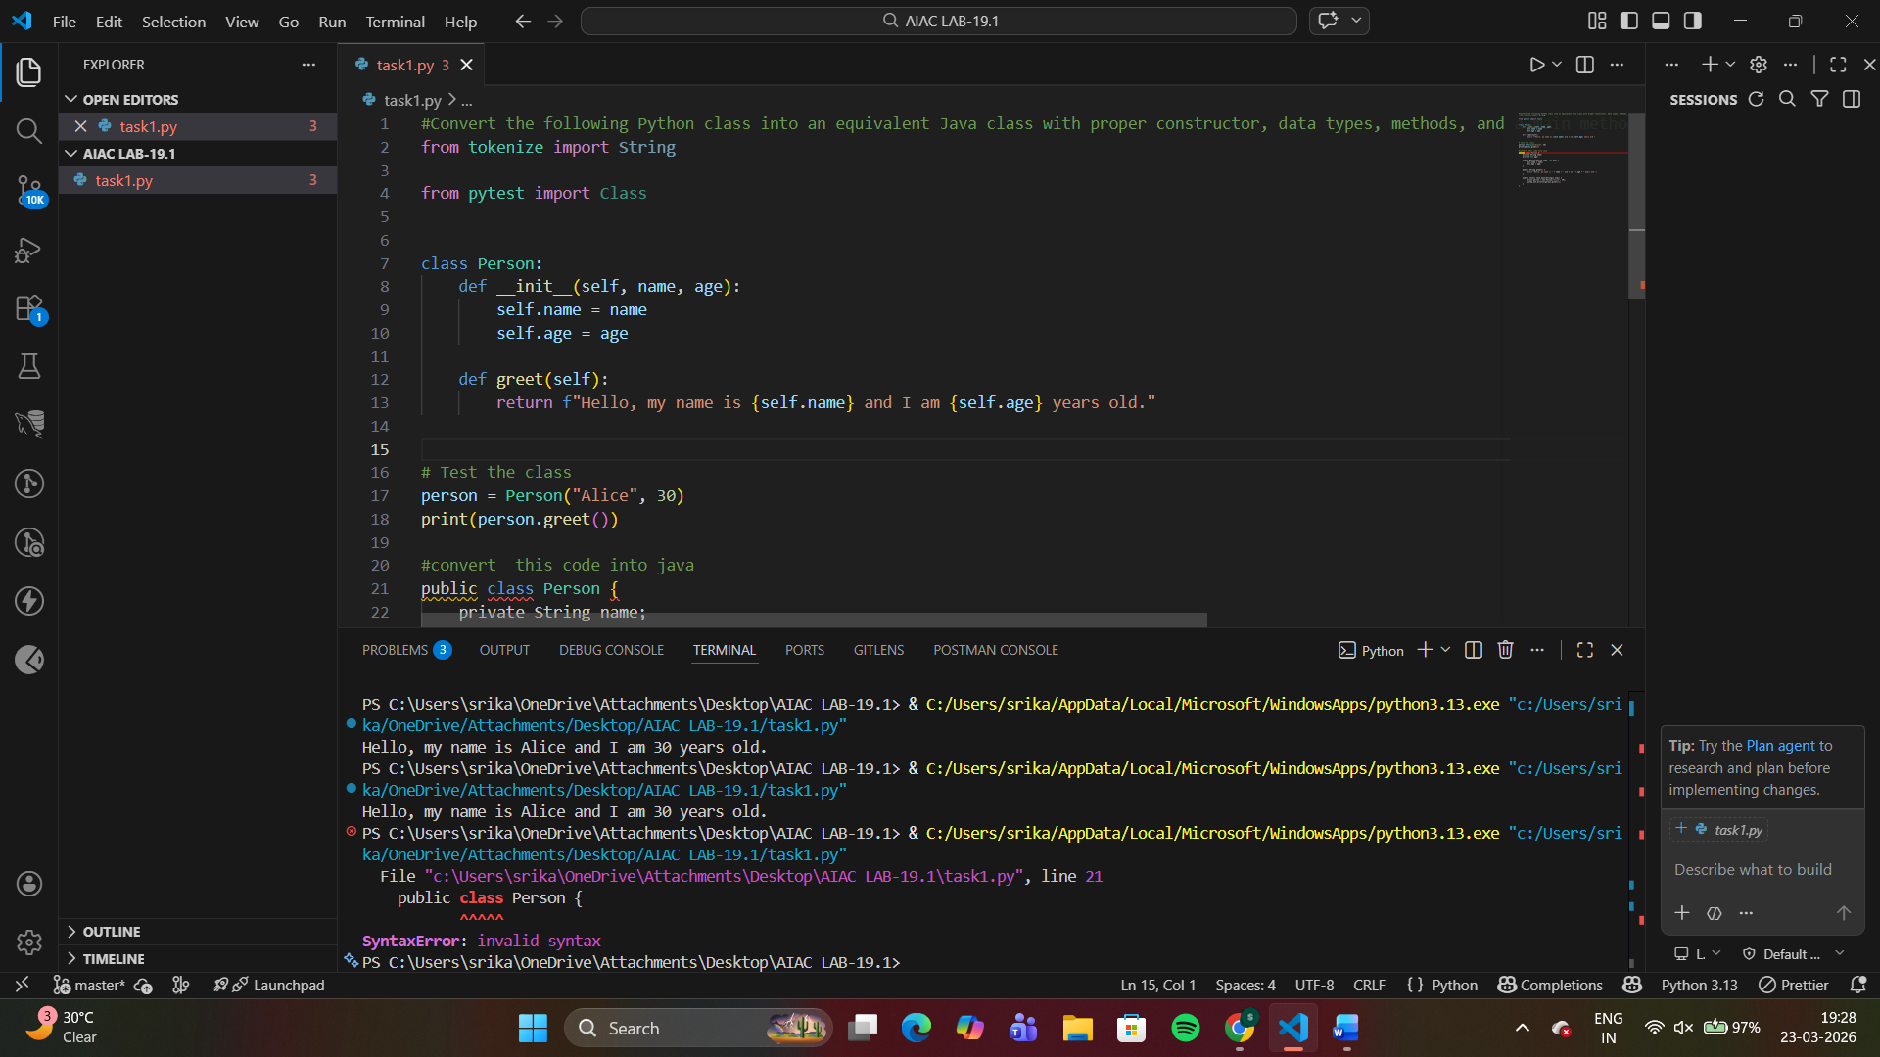
Task 2 – C++ to Python Function Conversion
Task:
Convert a C++ function for factorial calculation into Python.
Instructions:
• Ask AI to translate a recursive C++ factorial function into
Python.
• Validate correctness by testing with sample inputs.
• Ensure Python version follows Pythonic conventions.
Expected Output:
• A correct Python implementation equivalent to the original
C++ factorial function
difference
C++ | Python
int return type | No type needed
Curly braces {} | Indentation
cout | print()
Semicolons | No semicolons

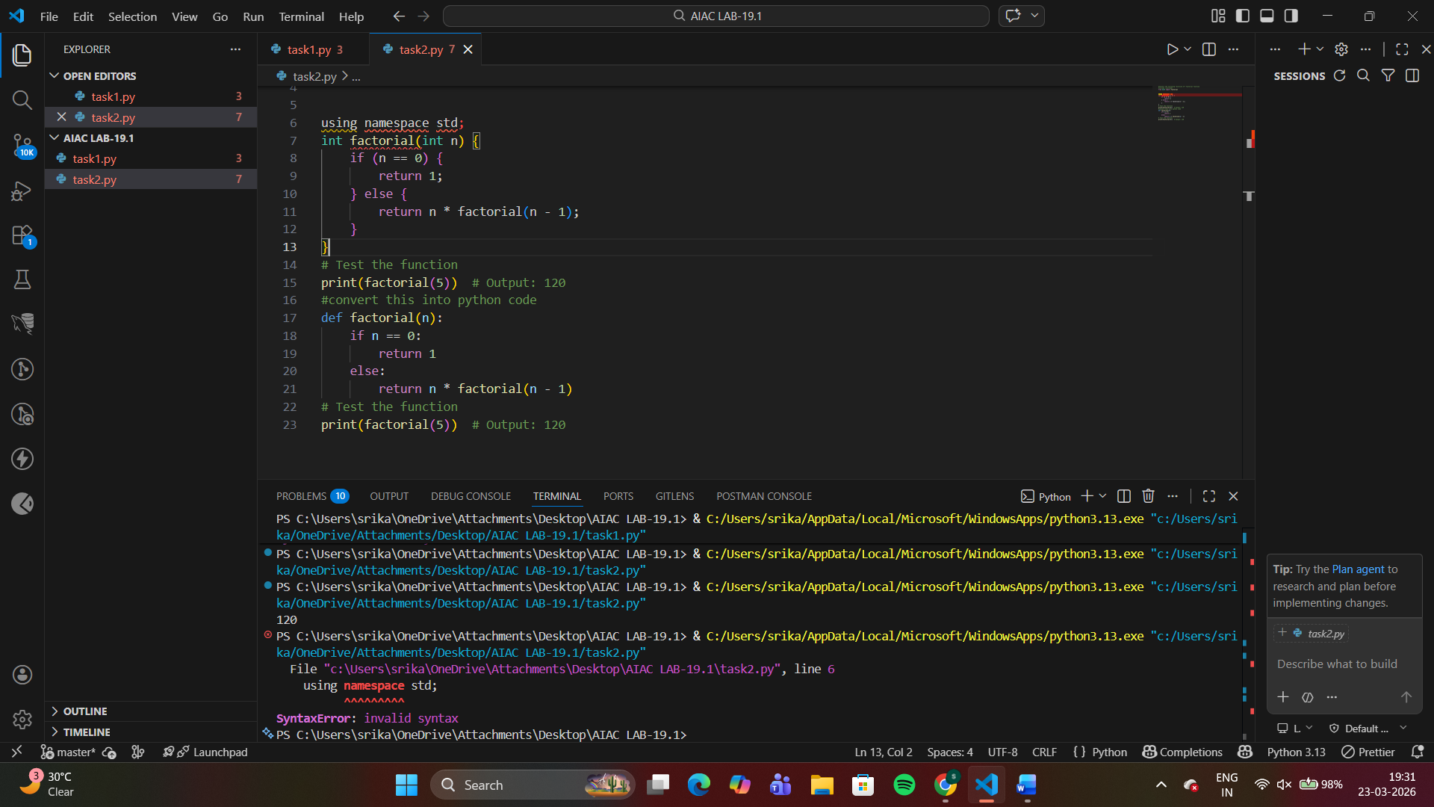
Task 3 – SQL to Pandas Query
Task:
Translate a SQL query into a Pandas DataFrame operation in
Python.
Instructions:
• Provide AI with a SQL query (e.g., SELECT name, salary
FROM employees WHERE salary > 50000).
• Ask AI to generate equivalent Pandas code.
• Test the generated code on a sample DataFrame.
Expected Output:
• Equivalent Pandas query that retrieves the correct subset of
data.
ANSWER
#Convert the following SQL query into an equivalent Pandas DataFrame operation in Python.
import pandas as pd
# Sample DataFrame
data = {
'name': ['Alice', 'Bob', 'Charlie'],
'age': [30, 25, 35]
}
df = pd.DataFrame(data)
# SQL Query: SELECT name FROM people WHERE age > 30;
# Equivalent Pandas operation
result = df[df['age'] > 30]['name']
print(result) # Output: 2 Charlie

import pandas as pd

# Create sample DataFrame (acts like table)
data = {
'name': ['Charan', 'Ravi', 'Amit', 'Sneha'],
'salary': [60000, 45000, 70000, 30000]
}

df = pd.DataFrame(data)

# Equivalent Pandas query
result = df[df['salary'] > 50000][['name', 'salary']]

# Print result
print(result)
import pandas as pd

# Create sample DataFrame
data = {
'name': ['Charan', 'Ravi', 'Amit', 'Sneha'],
'salary': [60000, 45000, 70000, 30000]
}

df = pd.DataFrame(data)

# Pandas equivalent of SQL
result = df[df['salary'] > 50000][['name', 'salary']]

# Output
print(result)
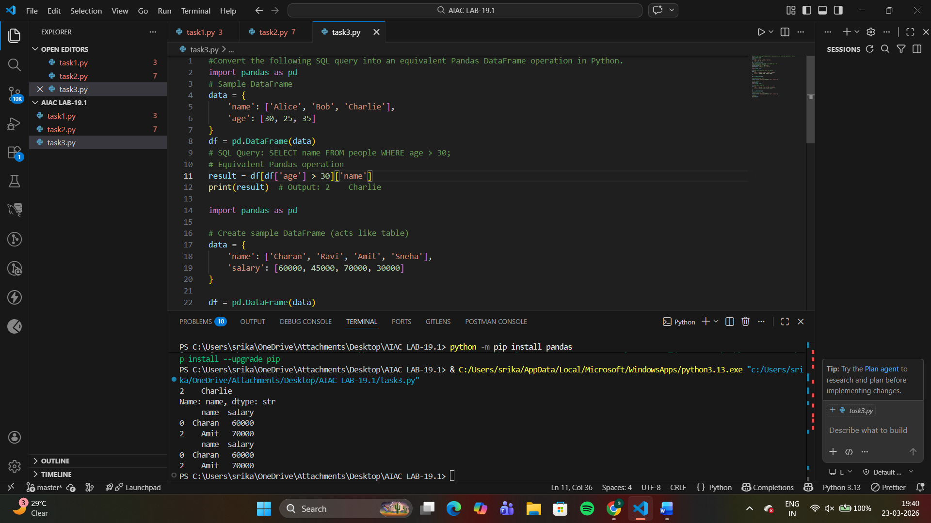
Task 4 – Real-Time Application: Multi-Language Snippet
Converter
Scenario:
Students will choose a real-time use case where they need code in
multiple languages. Example:
• Converting a Python web scraping snippet into JavaScript
for browser automation.
• Translating a Java method into C# for enterprise
applications.
Instructions:
• Prompt AI to translate code between two chosen languages.
• Test both implementations to ensure they produce the same
results.
• Document challenges faced during translation (e.g., syntax,
libraries).
Expected Output:
• Working equivalent code snippets in at least two different
programming languages.
ANSWER
Python
import requests

try:
response = requests.get("http://example.com") # use http (not https)
print("Status Code:", response.status_code)
except Exception as e:
print("Error:", e)

javascript
fetch("http://example.com")
.then(response => {
console.log("Status Code:", response.status);
})
.catch(error => console.log(error));
